

INDORE

“Blog Management Web Application”

A Project Report Submitted at
Universal Informatics, Indore
In partial fulfillment of the degree
Of
Bachelor of Engineering
In
Computer Science

Computer Science and Engineering Department
Universal Informatics
Indore-452003
2025

INDORE

“Real-Estate Web Application”

A Project Report Submitted at
Universal Informatics, Indore
In partial fulfillment of the degree
Of
Bachelor of Engineering
In
Computer Science

Guided By: Submitted By:
Mr. Anand Gupta Aditya Singh Deoda

Computer Science and Engineering Department
Universal Informatics
Indore-452003
2025

Acknowledgement

I would like to thank my Major Professor Mr.Anand Gupta for his constant help, encouragement and guidance throughout the project. I specially acknowledge his patience to help me figure out the right project to work on, providing me flexibility to implement my new ideas and provide valuable inputs for the project.

With Regards,
Aditya Singh Deoda

CERTIFICATE

This is to certify that Aditya Singh Deoda has completed their project work titled “Blog Management Web Application” as per the syllabus and submitted a satisfactory report on this project work.

Project Guide External Examiner
Mr. Anand Gupta

LIST OF FIGURES AND TABLES

FIGURES/TABLES | PAGE NO.
USE CASE DIAGRAM | 19
CLASS DIAGRAM | 20
SEQUENCE DIAGRAM | 28
ACTIVITY DIAGRAM | 28
DATA FLOW DIAGRAM | 30
E-R DIAGRAM | 31

Table of Contents

Contents

ABSTRACT
- INTRODUCTION
1.1 Problem Statement
  - Objectives
  - Scope
  - Platform Specification
1.4.1 Hardware Specification
1.4.2 Software Specification
1.4.3 Implementation Language
2. SYSTEM REQUIREMENT ANALYSIS
2.1 Identification of the Need
2.2 Priliminary Investigation
3. FEASIBILITY STUDY
3.1 Technical Feasibility
3.2 Economic Feasibility
3.3 Operational Feasibility
4. LITERATURE SURVEY
4.1 Benefits
4.2 Proposed Solution
4.3 Technology Used
5. TECHNICAL PART
5.1 Project Standard
5.2 Proposed Tools
5.3 Description of Hardware and Software
5.4 Interfaces
5.5 Security
5.6 Coding Language
6. SOFTWARE ENGINEERING APPROACH
6.1 Software Engineering Paradigm Applied
6.1.1 Description
6.1.2 Advantages and Disadvantages
6.1.3 Reasons for Use
6.2 Requirement Analysis
6.2.1 Software Requirement Specification
6.2.2 Conceptual Level Class Diagram
6.3 Planning Managerial Issue
6.3.1 Planning Scope
6.3.2 Team Organization
6.3.3 Project Scheduling
6.3.4 Estimation
6.3.5 Risk Analysis
6.3.6 Security Plan
6.4 Design
6.4.1 Design Constraints
6.4.2 Design Techniques
6.4.3 Modelling
SCREENSHOTS

ABSTRACT
The Blog Management Web Application is a robust and user-friendly platform built using Spring MVC, Hibernate ORM, and MySQL. It enables users to register, create, edit, and manage blogs seamlessly. The application provides categorized blog reading, interactive commenting, and profile customization features.

A dedicated admin dashboard allows administrators to moderate content, manage users, and enforce platform policies by deleting inappropriate blogs or comments and blocking users if necessary. The integration of Hibernate ORM ensures efficient database interactions, while Spring MVC provides a structured and scalable framework for smooth functionality.

This project demonstrates the power of Java-based web applications, leveraging Spring’s MVC architecture for modular design and Hibernate ORM for efficient data management, making it an ideal solution for dynamic content management.

1.INTRODUCTION

1.1 Problem Statement
In today's digital era, content creation and sharing have become an essential part of online communication. However, many traditional blogging platforms lack user-friendly interfaces, efficient content management, and administrative control. Our Blog Management System is designed to overcome these challenges by providing a structured platform where users can create, edit, and manage blog posts efficiently. It also allows an administrator to oversee the system, ensuring appropriate content management and user access control.

1.2 Objectives

- To develop a user-friendly blogging platform for content creation and management.
- To allow users to register, create, edit, and delete their blog posts.
- To enable categorized browsing of blog content.
- To implement a commenting feature for user engagement.
- To provide an admin dashboard for content moderation and user management.
- To ensure security and authentication for users and admins.
- To allow users to upload a blog image when adding a blog.
- To enable users to have their own profile image.

1.3 Scope

The Blog Management System provides a platform for users to express their thoughts and share knowledge through blogs. It ensures an organized structure for content creation, administration, and management. The system will be useful for individual bloggers, organizations, and educational institutions aiming to maintain an online presence.

1.4 Platform Specification

1.4.1 Hardware Specification

- A I3/I5 processor running at 400 MHz or faster
- Random Access Memory (RAM)
- 4GB recommended
- TCP/IP network interface card
- Local area network (LAN) card and persistent Internet connection is required.
256 GB hard disk is required.

1.4.2 Software Specification

- Microsoft Windows /Linux.
- Internet Explorer.
- Jdk1.8 or higher.
- Jakarta Tomcat as Web Server.
- MySQL as Database

    - Implementation Language

- Backend: Java (Spring MVC, Hibernate ORM)
- Frontend: HTML, CSS, JavaScript
- Database: MySQL

2. SYSTEM ANALYSIS

Systems analysis is the interdisciplinary part of Science, dealing with analysis of sets of interacting or entities, the systems, often prior to their automation as computer systems, and the interactions within those systems. This field is closely related to operations research. It is also "an explicit formal inquiry carried out to help someone, referred to as the decision maker, identify a better course of action and make a better decision than he might otherwise have made.

2.1 Identification of the need

Traditional blog management systems often face challenges such as lack of content moderation, difficulty in user authentication, and inefficient categorization. This system aims to provide a structured approach where users can interact seamlessly while administrators ensure content integrity.

2.2 Preliminary Investigation

Existing platforms like WordPress and Blogger have extensive features, but they may be complex for non-technical users. Our system simplifies blog management by focusing on core functionalities like user registration, content creation, and moderation.

3. FEASIBILITY STUDY
A feasibility study is a preliminary study undertaken to determine and document a project's viability or the discipline of planning, organizing, and managing resources to bring about the successful completion of specific project goals and objectives. The term is also used to describe the preliminary analysis of an existing system to see if it is worth upgrading all or a part. Also known as feasibility analysis. The term is also used to refer to the resulting document. The results of this study are used to make a decision whether or not to proceed with the project. If it indeed leads to a project being approved, it will before the real work of the proposed project start and be used to ascertain the likelihood of the project's success. It is an analysis of possible alternative solutions to a problem and a recommendation on the best alternative. It can decide, for example, whether order processing can be carried out by a new system more efficiently than the previous one.
If a project is seen to be feasible from the results of the study, the next logical step is to proceed with it. The research and information uncovered in the feasibility study will support the detailed planning and reduce the research time.
The feasibility study is done to find whether the system is beneficial to user end and organization or not. The feasibility study is carried out to select the best system that meets performance requirements. Once a relevant team member recognizes a need then the proposed system is with reference to certain parameters relates to our organization. With reference to each given below parameter, the fact is determined that “whether the system is practicable or not” and after only this evaluation system will be proceed. Parameters are given below.

3.1 Technical Feasibility
- The system will be implemented using Java, Spring MVC, Hibernate ORM, and MySQL.
- A web-based interface will be developed using HTML, CSS, and JavaScript.
- The platform will run on Tomcat Server.
3.2 Economic Feasibility
- No significant investment is required beyond hosting and database management.
- Open-source frameworks and technologies will be used to keep costs minimal.

3.3 Operational Feasibility
- The system is designed to be user-friendly, making it accessible to non-technical users.
- Training requirements are minimal due to the intuitive UI.

4. LITERATURE SURVEY
Before a project is undertaken it is essential that the previously developed similar attempts are studied and referred for getting a brief over view of the requirements, schemas and other constraints.
4.1 Benefits
This system has the following benefits :-
- User-friendly interface for bloggers and readers.
- Categorized blog management for easier navigation.
- Role-based access control for security.
- Secure user authentication and content moderation.
- Users can upload a blog image when adding a blog.
- Users can have their own profile image.
4.2 Proposed Solution
The proposed Blog Management System offers a comprehensive web-based platform with essential functionalities, including:
- User Authentication: Secure login and registration process to ensure authorized access.
- Blog Content Management: Users can create, edit, and delete their blog posts effortlessly.
- Content Categorization: Blogs can be categorized under different topics for better organization and navigation.
- Commenting System: Users can engage with blogs by adding and deleting comments.
- User Profile Management: Each user has a profile where they can manage their personal information.
- Administrative Control Panel: Admins have access to a dashboard for:
  - Moderating blog content and comments.
  - Managing user accounts, including blocking or deleting users if necessary.
  - Overseeing overall blog activities and ensuring compliance with platform policies.
This system is designed to enhance user engagement, streamline content management, and provide a secure environment for blogging.
4.3 Technology Used
Backend:
- Java: A high-level, object-oriented programming language used for building scalable web applications. It provides platform independence and strong security features.
- Spring MVC: A framework for building web applications using the Model-View-Controller (MVC) design pattern. It provides dependency injection, flexible configuration, and integration with other Java-based technologies.
- Hibernate ORM: An Object-Relational Mapping (ORM) framework that simplifies database interactions by converting Java objects into database records and vice versa, reducing the need for complex SQL queries.
Frontend:
- HTML (Hypertext Markup Language): The standard markup language used to create the structure of web pages.
- CSS (Cascading Style Sheets): A stylesheet language used for designing and styling web pages, ensuring a responsive and visually appealing interface.
- JavaScript: A programming language that enables interactive features such as dynamic content updates, form validation, and asynchronous communication with the server.
Database:
- MySQL: A popular open-source relational database management system (RDBMS) that supports structured data storage, indexing, and querying with SQL. It ensures data integrity and security for blog posts, user accounts, and comments.
Web Server:
- Apache Tomcat: An open-source web server and servlet container that executes Java Servlets and Java Server Pages (JSP). It provides a secure and efficient runtime environment for Java-based web applications.

5. TECHNICAL PART
5.1 Project Standard
This simulation is a web-based application.
5.2 Proposed Tools
- MySQL, Eclipse 22-12
5.3 Description of hardware and software
Software
- Microsoft Windows /Linux.
- Google Crome.
- Jdk 1.8 or higher.
- Jakarta Apache Server as Web Server.
- MySQL as Database
Hardware
- A I3/I5 processor running at 400 MHz or faster
- Random Access Memory (RAM)
- 4 GB recommended
- TCP/IP network interface card
- Local area network (LAN) card and persistent Internet connection is required.
- 256 GB hard disk is required.
5.4 Interfaces
The Blog Management System provides multiple interfaces for different types of users:
- User Interface: A web-based interface that allows users to register, log in, create, edit, and delete blogs, as well as add and manage comments.
- Admin Interface: A dashboard for administrators to monitor user activities, approve or delete blogs and comments, and manage user accounts.
- Database Interface: The system interacts with MySQL to store and retrieve blog data, user details, and comments securely.
- REST API Interface: Enables seamless communication between the frontend and backend, ensuring smooth data transactions.
- Authentication Interface: Ensures secure login and session management for users and administrators.

5.5 Security
This system is secured as each user is provided a password. Only a registered person can log in to the system. And no one except admin is allowed to make any changes to the database. Thus this system is totally secured.
5.6 Coding language
In OSTM we used Java. Java was conceived by James Gosling, Patrick Naughton, Chris Warth, and Mike Sheridan at Sun Microsystems, Inc. in 1991. It was initially called “oak” but was renamed “java” in 1995. Java is a simple, object-oriented language. Java buzzwords:
- Simple:- Java was designed to be easy for the professional programmer to learn and use effectively. If you are an experienced C++ programmer moving to java will require little effort because Java inherits the C/C++ syntax and many of the object=oriented features of C++.
- Object-oriented:- Java has a clean, usable, pragmatic approach to objects. Java manages to strike a balance between the purist’s “everything is an object” paradigm and the pragmatist’s “stay out of my model”. The object model in java is simple and easy to extend, while primitive types such as integers, are kept as high-performance non objects.
- Robust:- The ability to create robust programs was given a high priority in java. Because java is a strictly typed language, it checks code at compile time. However, it also checks code at run time. Java manages memory allocation, deallocation, exceptional conditions, all run time errors.
- Multithreaded:- Java supports multithreaded programming, which allows you to write programs that do many things simultaneously.
- Dynamic:- Java programs carry with them substantial amounts of run time tye information that is used to verify and resolve accesses to objects at run time. This makes it possible to dynamically link code in a safe and expedient manner.
Spring MVC:
- A powerful Java framework for building web applications following the Model-View-Controller (MVC) architecture. It simplifies web application development by separating business logic, user interface, and request handling.
- Model: Represents the application's data and business logic. It interacts with the database using Hibernate ORM to retrieve and manipulate blog-related information.
- View: Defines how the data is presented to users. It uses JSP (Java Server Pages) and frontend technologies like HTML, CSS, and JavaScript to render the interface.
- Controller: Manages user requests and responses. It processes HTTP requests, interacts with the Model, and returns the appropriate View.
Spring MVC also provides:
- Dependency Injection: Helps manage object dependencies efficiently, improving modularity and testability.
- Request Mapping: Maps client requests to specific controller methods using annotations like @RequestMapping.
- Form Handling & Validation: Simplifies user input validation through @Valid and BindingResult.
- Security & Authentication: Easily integrates with Spring Security for role-based access control.
- REST API Support: Enables seamless communication between frontend and backend with @RestController and JSON responses.
Spring MVC ensures the Blog Management System is scalable, maintainable, and easy to develop by leveraging these robust features.

JAVA SERVER PAGES:
Java Server Pages (JSP) is a Java technology that allows software developers to dynamically generate HTML, XML or other types of documents in response to a Web client request. The technology allows Java code and certain pre-defined actions to be embedded into static content.
The JSP syntax adds additional XML-like tags, called JSP actions, to be used to invoke built-in functionality. Additionally, the technology allows for the creation of JSP tag libraries that act as extensions to the standard HTML or XML tags. Tag libraries provide a platform independent way of extending the capabilities of a Web server.
JSP are compiled into Java Servlets by a JSP compiler. A JSP compiler may generate a servlet in Java code that is then compiled by the Java compiler, or it may generate byte code for the servlet directly. JSP can also be interpreted on-the-fly reducing the time taken to reload changes.
6. SOFTWARE ENGINEERING APPROACH
6.1 Software Engineering Paradigm Applied
In this simulation we are using Waterfall Model.
6.1.1 Description
Waterfall model is the oldest software paradigm. This model suggests a systematic, sequential approach to software development. This model is also called linear-sequential model. The software development starts with requirements gathering phase. Then progresses through analysis, design, coding, testing and maintenance.
In requirement gathering and analysis phase the basic requirements of the system must be understood. All these requirements are then well documented.
Design focuses on program attributes such as data structure, software architecture, interface representation, algorithmic details.
Coding is a step in which design is translated into machine-readable form. Programs are created in this phase.
Testing begins when coding is done. While performing testing the major focus is on logical internals of the software. The testing ensures execution of all the paths, functional behaviors. The purpose of testing is to uncover errors, fix the bugs and meet the requirements.
Maintenance is the longest phase. When the system is installed and put in practical use then error may get introduced, correcting such errors and putting it in use is the major purpose of maintenance activity

.
Requirement gathering and Analysis
Design

Coding

Testing

Maintenance

Fig. Waterfall Model

6.1.2 Advantages and Disadvantages
Advantages-
- Waterfall model is simple to implement.
- For implementation of small systems waterfall model is useful.

Disadvantages-
- It is difficult to follow the sequential flow in software development process.
- The requirement analysis is done initially and sometimes it is not possible to state all the requirements explicitly in the beginning.

6.1.3 Reasons for use
We are using waterfall model in this simulation since it is easy to implement. All the requirements for developing this software are explicitly declared.

6.2 Requirement Analysis
A Requirement is a feature of the system or a description of something; the system is capable of doing in order to fulfill the system purpose. Requirement Engineering provides the appropriate mechanism for understanding what the customer wants, analyzing needs, assessing feasibility, negotiating a reasonable solution, validating the specification and managing the requirements as they are transformed into an operational system. Our application package helps the planner and manager in a guided way to perform his/her tasks in effective manner even if he is unaware of the details of the software program. The objective of any value added package or application program is to support and decision-making and analysis.

6.2.1 Software Requirement Specification
It is an s/w engineering task that bridges the gap b/w system level requirement engineering and s/w design. Requirement analysis allows the s/w engineer to refine s/w requirement and build models of data, functional and behavioral domain that will be treated by s/w.

6.2.1.1 Glossary
- Activity Diagram – A diagram that shows flow from activity to activity.
- GUI – A Graphical User Interface that has windows, buttons and menus used to carry out -
- Project – Any piece of work that is undertaken or attempted.
- Report – A written document describing the findings of some individual or group.
- Sequence Diagram – An interaction diagram that emphasizes the time ordering of messages.

6.2.1.2 Supplementary Specification
The Java Servlet API allows a software developer to add dynamic content to a Web server using the Java platform. The generated content is commonly HTML, but may be other data such as XML. Servlets are the Java counterpart to non-Java dynamic Web content technologies such as PHP, CGI and ASP.NET. Servlets can maintain state across many server transactions by using HTTP cookies, session variables or URL rewriting.
The Servlet API, contained in the Java package hierarchy javax.servlet, defines the expected interactions of a Web container and a servlet. A Web container is essentially the component of a Web server that interacts with the servlets. The Web container is responsible for managing the lifecycle of servlets, mapping a URL to a particular servlet and ensuring that the URL requester has the correct access rights.

6.2.1.3. Use Case Model
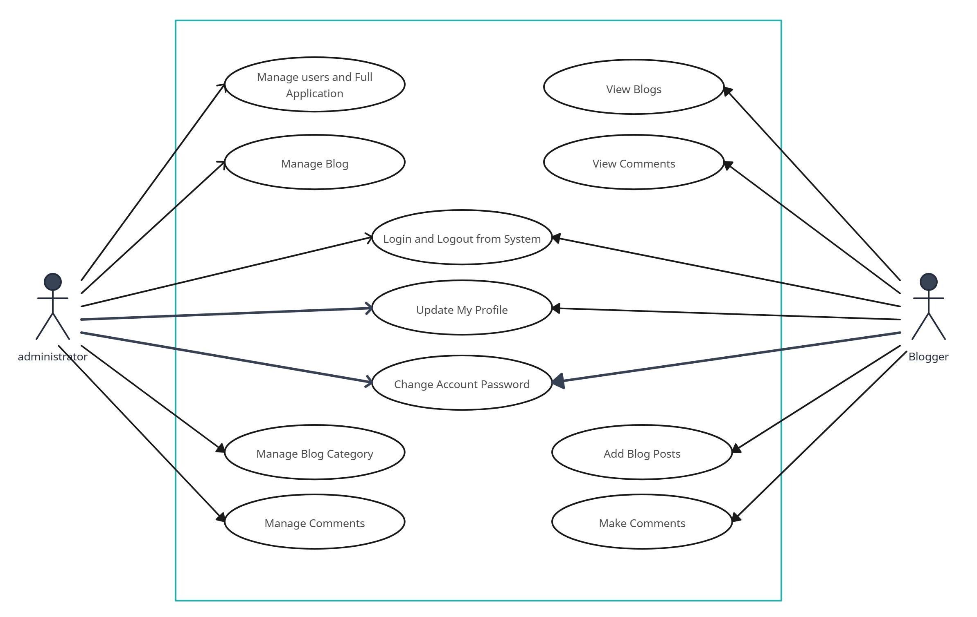

6.2.2. Conceptual Level Class Diagram:
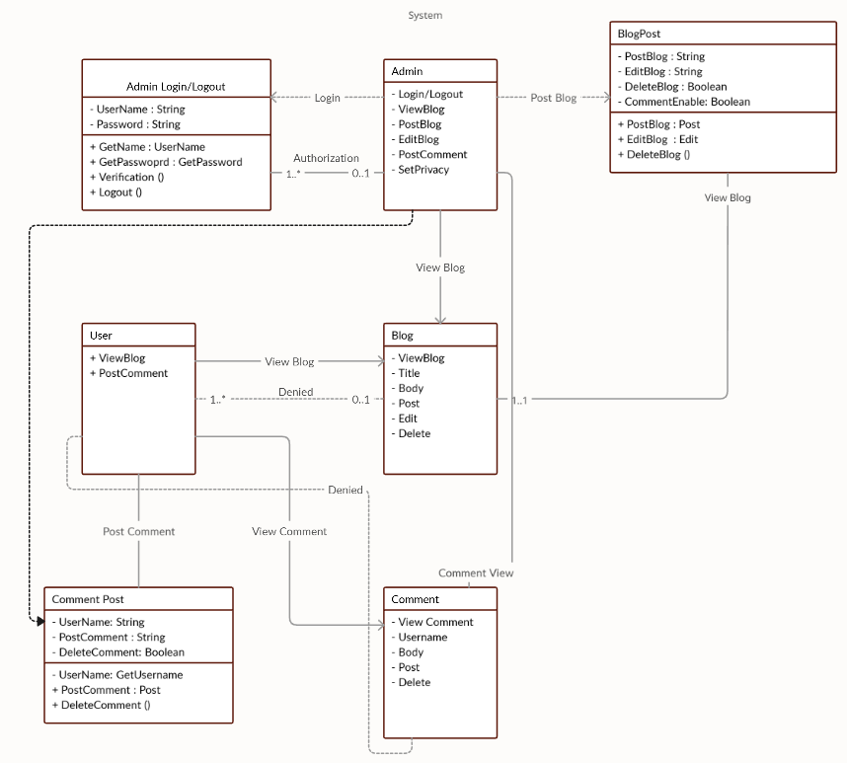

6.3 Planning Managerial issue
6.3.1 Planning scope
The Blog Management System is designed as a web-based platform to facilitate the creation, management, and moderation of blogs. The system aims to provide:
- A structured environment for content creation and user engagement.
- A role-based access system, differentiating users and administrators.
- Secure authentication and access control mechanisms.
- Scalability to accommodate future feature enhancements.
- Cross-platform accessibility for seamless user experience on different devices.
In present scenario, with the increasing competition and time shortage, every manual system needs automation. Internets become essential part of the day to day life. This utility is used by almost everyone in his day to day life. There is a need for a system which can provide accurate information in less time.
This system upon receiving the requests looks-up the underlying database and sends the appropriate response to the user.

6.3.2 Team Organization
Our Team Structure is Democratic Decentralized.
In Democratic Decentralized team structures following features are observed:
C
C
C
AB
BAB

A - Project Guides
B - Information source (Books and Internet)
C –Team member

- It has no team leader. All players are at the same level.
- Problem solving is done in-groups.
- It has high degree of sociability.
- It is generally employed for small projects.

All the above stated properties are observed in our project. Thus, the team structure of our project is Democratic Decentralized.
6.3.3 PROJECT SCHEDULING
Project is completed within 3 months.
Timeline Chart

Activity. No. | Work Task | M1 | M2 | M3 | M4 | M5 | M6 | M7
1.1.1 | Meeting Knowledgeable People
1.1.2 | Identifying Requirements
1.1.3 | Identifying Constraints
1.1.4 | Study Problem Statement
1.1.5 | Identify Project Definition
1.1.6 | Establish Goals of the Project
1.1.7 | Analyze Benefits
1.1.8 | Establish Scope of Project
1.1.9 | Advantages and Disadvantages
1.1.10 | Requirement Documentation
1.1.11 | Requirement Specification
1.1.12 | Normal, Expected, Exciting Req.
1.1.13 | General Types of Requirements
Milestone 1
1.2.1 | Study of various process models
1.2.2 | Selection of a Process Model
1.2.3 | Study advantages/disadvantages
1.2.4 | Define Human Resources
1.2.5 | Define Reusable Resources
1.2.6 | Define Environment Resources
1.2.7 | Project Team Organization
1.2.8 | Work Style

6.3.4 Estimation
Effective software project estimation is one of the most challenging and important activities in software development. Proper project planning and control is not possible without a sound and reliable estimate. As a whole, the software industry doesn’t estimate projects well and doesn’t use estimates appropriately.
The four basic steps in this software project estimation are:
- Estimate the size of the development product. This generally ends up in either Lines of Code (LOC) or Function Points (FP), but there are other possible units of material referenced at the end of this report.
- Estimate the efforts in person-months or person-hours.
- Estimate the schedule in calendar months.
- Estimate the project cost in rupee.
6.3.5 Risk Analysis
Risk analysis and management arc a series of steps that help a software team to understand and manage uncertainty. A risk always involves two characteristics.
1) Uncertainty – The risk may or may not happen; that is, there are no 100% probable risks.
2) Loss - If the risk becomes a reality, unwanted consequences or losses will occur.

TYPES OF RISK

A risk is any unfavorable event or circumstance that can occur while a project is underway. If a risk becomes true, it can hamper the successful and timely completion of a project. Therefore, it is necessary to anticipate and identify different risks that a project is susceptible to, so that a contingency plan may be prepared in advance to contain the effects of each risk. Risk management aims at dealing with all kinds of risks that might affect a project.
We quantify the level of uncertainty and the degree of loss associated with each risk, when we analyze the different categories of risks that are considered.

- PROJECT RISK

Project risks threaten the Project Plan. For example, if a project risk occurs in reality, then it is likely that the project schedule will slip and that the costs will increase. Project risks identify potential budgetary, schedule, personnel, resource, customer, and requirements problems and their impact on a software project.

- TECHNICAL RISK

Technical risks threaten the quality and timeliness of the software to be produced. A technical risk makes implementation difficult or at times, impossible. Technical risks identify the potential design, implementation, interfacing, maintenance, and verification problems.

- BUSINESS RISK

Business risks threaten the viability of the software to be built. Business risks often jeopardize the product or project. This risk occurs when a product or a system is built correctly but is not wanted in the market (known as Market Risk), or when a product is built without keeping the overall business strategy of the company in mind (known as Strategic Risk), or when a product does not fetch the price in the market it is expected to (known as Sell Risk), or when the team members do not work cohesively towards completing the product (known as Management Risk), or when the cost of the product exceeds the budgetary allocation (known as Budget Risk).

- KNOWN RISK

Known risks are those risks that are previously known to the developers. These risks include the delays related to the delivery date of the project.

- PREDICTABLE RISK

Predictable risks are risks that can be foretold based on experience gained in developing past projects, or in developing previous segments of the current project. For example, a risk ignored in the analysis phase is likely to cause a risk in the design phase.

- UNPREDICTABLE RISK
Unpredictable risks are undesirable events that occur unexpectedly. This type of risk covers such situations like the one where the user changes his requirements during the development of the project.

6.3.6 Security plan
This system is secured as each user is provided a password. Only a registered person can log in to the system. And no one except admin is allowed to make any changes to the database. Thus, this system is totally secured.
6.4 DESIGN
6.4.1 Design Constraints
Design constraints of the system involve the limitations provided to the user as user cannot make any changes to the database, user can access his account only. Broker is also bounded by some limitations as he cannot alter the database, he can only add or delete the customer, can do the trading for customer. And administrator has all the rights over the database, all trading activities are done under the supervision of the administrator
6.4.2. Design Techniques

In our project we are following Object Oriented Design strategy. The software product can be designed using structured oriented method or using object-oriented techniques. There are some merits and demerits associated with these systems which directly affect the software development process. The object-oriented analysis is a technique in which main emphasis is on objects. Each object is a combination of data members and member functions. The use cases, class diagrams, sequence diagrams, state chart diagram, activity diagram, component diagrams can be drawn in this method.

6.4.3. Modelling
6.4.3.1. Class Diagram
6.4.3.2. Sequence Diagram

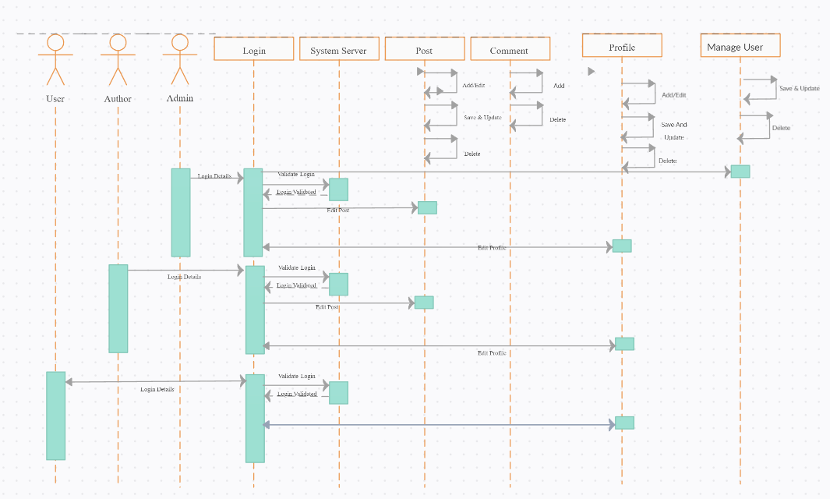
6.4.3.3. Activity Diagram
For Administrator:

Login
View Blogs
List Users

Logout
Manage Blogs
Block users

Manage Comments
6.4.3.4. Data Flow Diagram

6.4.3.4.1. Level 0 Data Flow Diagram

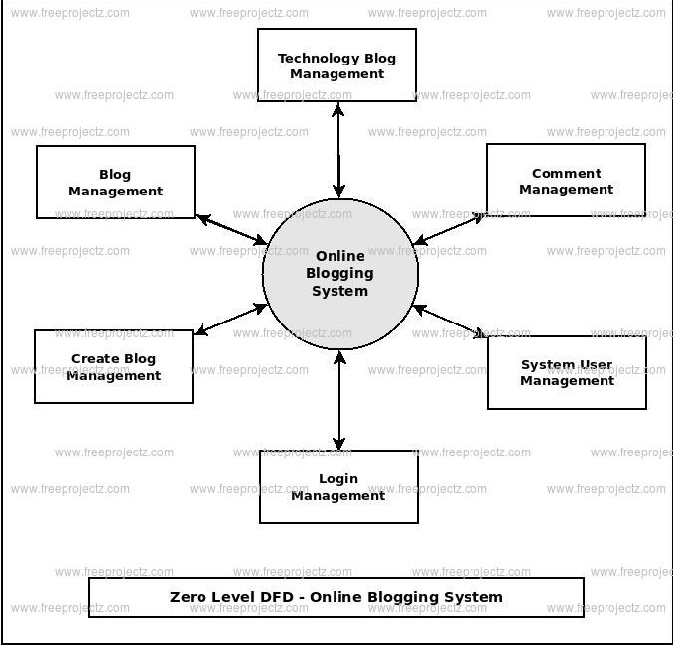

6.4.3.4.2. Level 1 Data Flow Diagram
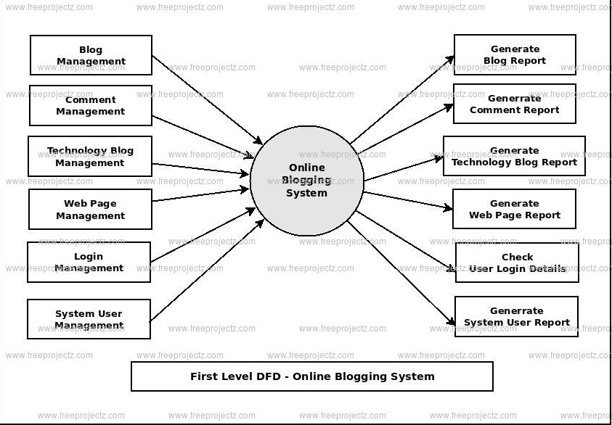
6.4.3.4.3. Level 2 Data Flow Diagram
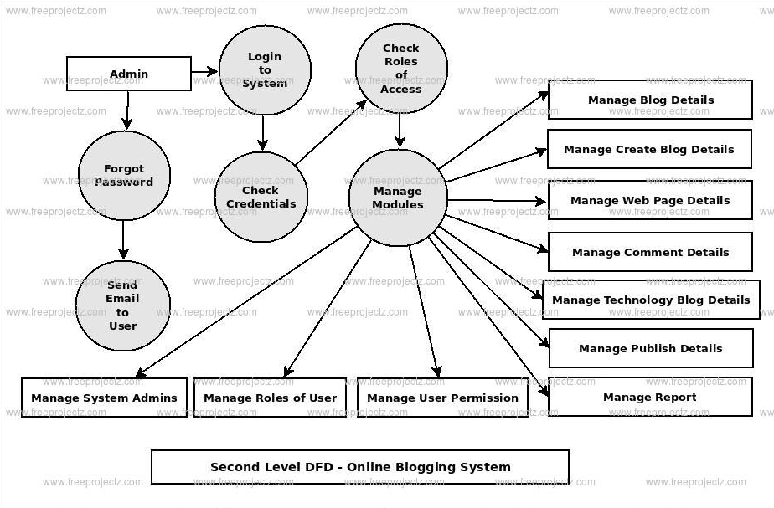
6.4.3.5. E-R Diagram:

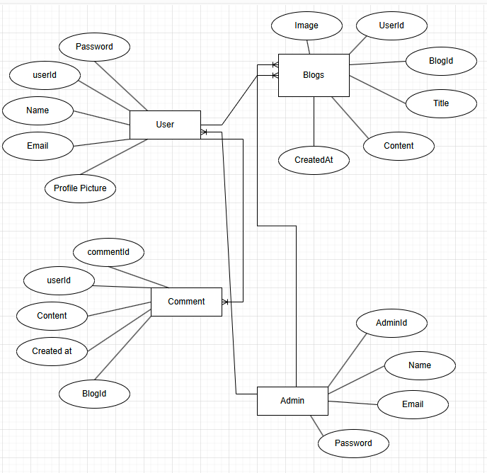

Screenshots:

